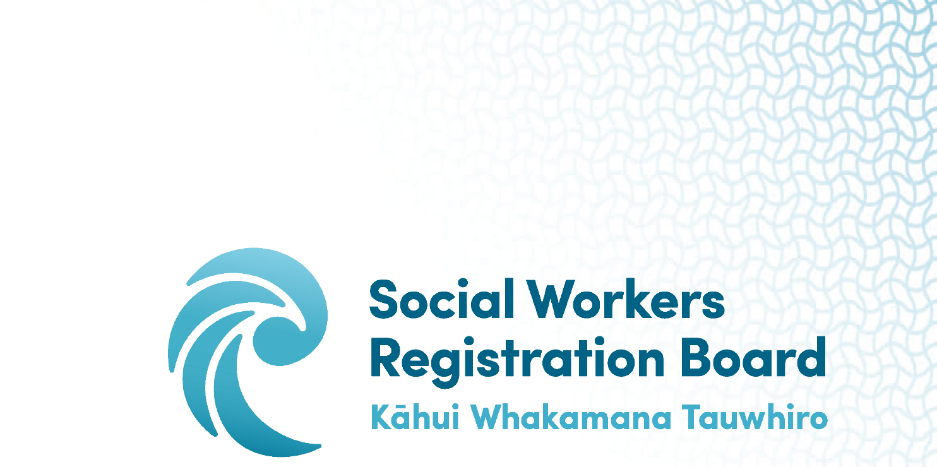

WĀNANGA FOR THE REVIEW OF THE SWRB PROGRAMME RECOGNITION STANDARDS:

ADDITIONAL FEEDBACK FORM

Consultation for the 2022 review of the SWRB Programme Recognition Standards will occur during the six scheduled wānanga, the interactions within the review working team, the reference group and a period of public consultation.
Additional feedback is welcome from individuals, and you are invited to use this form. It is based on the pātai posed during the wānanga, with additional space for other feedback. It will have most impact if we receive it before May 9th.
Please send this completed form to the kaiwhakahaere for the review:
Shirley Ikkala shirlikka@outlook.co.nz and Carole Adamson ceadamson@hotmail.com

SWRB Programme Recognition Standards Review: Feedback to review working team
Theme(s) of the Programme Recognition Standards (PRS) you are giving feedback on.
How should Te Tiriti o Waitangi shape the PRS?

How could the moemoeā
Manaaki Tangata, Manaaki Whānau
Looking after one another, looking after our whānau
shape the PRS?

How can each Takepū give expression to the PRS?
- Kaitiakitanga

- Rangatiratanga

- Manaakitanga

- Whanaungatanga

Your additional comments:

Name:

Email address:

