

Why are you being asked to complete a reflective template?
- You are being asked to complete this document because you declared you have convictions or we have been advised by the Vetting Service that you have convictions
- This is your opportunity to provide us with context and your reflection on the police vetting results
- The Criminal Records (Clean Slate) Act 2004 does not apply. The SWRB vets under the Children’s Act 2014 which means it is full disclosure at the discretion of the New Zealand police
- Having convictions may not prevent you from becoming a registered social worker. With insight, your experiences can add to what you have to offer the profession.
- Convictions are taken into consideration alongside your:
  - Your insight into your past conduct;
  - The circumstances leading to your conviction(s);
  - The impact that this experience has had on you as a result;
  - How the experience will influence your social work practice; and
  - Why you believe that the conviction(s) does not, and will not in the future, reflect adversely on your fitness to practise as a social worker in New Zealand.
- The information you provide will inform and help us to make a decision about your application
- If you have any questions, please contact your registration officer who is there to help


Process for completing the reflective statement for applicants
- Please complete this reflective statement with as much information as possible
- If you mention supporting information, please provide it or give reasons why you cannot provide it e.g. if you say “I attended a course on stopping violence” please provide as much evidence as you can to support the times, dates and facilitator details
- Once you have completed the reflective statement please submit it with the rest of your documents for your application for registration
- We may ask you for more information along the way to support your application
- When your documents are processed your Request and Consent vetting form will be submitted to the Vetting Service. Once we receive the results your registration officer will be in contact regarding next steps for your application
- Once we have all the information for your application to be processed, we will make a recommendation to the Board regarding your application for registration.
- We will inform you of the outcome of the Board’s decision on your registration

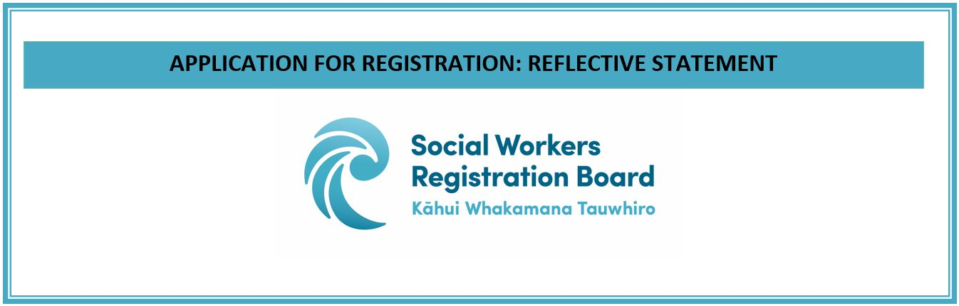
Reflective Statement | Reflection allows you to critically think about what you have learnt from experiences, and how your experiences will influence your social work practice.  This reflective declaration includes the following components:  - The circumstances leading to your conviction(s);  - The impact that this experience has had on you as a result;  - How the experience will influence your social work practice; and  - Why you believe that the conviction(s) does not, and will not in the future, reflect adversely on your fitness to practise as a social worker in New Zealand.
Name of applicant: |  | Click or tap here to enter text.
Date of events leading to your conviction(s): |  | n
Nature of the conviction(s): |  | Click or tap here to enter text.
Please describe the circumstances of your conviction(s):
Click or tap here to enter text.

Please provide a reflection regarding your conviction(s) including any impacting factors that may have contributed to conviction(s) and any impacts this experience may have had on the public.
Click or tap here to enter text.

How will the experience enhance your social work practice?
Click or tap here to enter text.

Why do you believe that the conviction(s) does not, and will not in the future, reflect adversely on your fitness to practise as a social worker in New Zealand?
Click or tap here to enter text.

What interventions have you undertaken to address the offending i.e. Alcohol and Drug counselling, supervision, attended courses or received support (please attach any evidence to your application or leave this section blank if no interventions have been undertaken):
Click or tap here to enter text.

Signature of applicant: |  |  | Date (dd/mm/yyyy):
Click or tap here to enter text. |  |  | Click or tap to enter a date.

Please note, depending on the nature of your conviction(s) you may be asked to provide a safety plan (how you practise safely) and a character reference. A registration officer will be in contact with you if this is required.

Adapted from the Physiotherapy Board of New Zealand

